CHAPTER 7: CLASSES AND OBJECTS
TOPICS COVERED:
7.1 VARIOUS DEFINITIONS OF CLASS & OBJECT
7.2 RULES TO CREATE A CLASS
7.3 VARIABLES USED IN CLASS
7.4 USE OF SELF KEYWORD
7.5 USE OF __init__ CONSTRUCTOR
7.6 PROPERTIES OF OOPS

7.1 VARIOUS DEFINITIONS OF CLASS
Classes in python are describes as,
- Collection of objects with data model (class) references of it self
- Creating local name spaces
- Namespaces to mapping names into objects
- Namespace objects with specific lifetime
- User defined data structure to create objects
- Prototype for creating objects
- Prototype which allows creating new objects with data model
Class is a collection of,
- States and behaviors
- Data and functions
- Variables and members
- Data variables and member functions
- Properties and methods
Object is the instance (data model) of class which is a copy of class with actual values.
Object contains the following in it,
State: This reflects object properties
Behavior: This reflects responses between different objects
Identity: Unique name given to interact with different objects

7.2 RULES TO CREATE A CLASS
Python interpreter provides and follows some specific rules while supporting OOPs. There are,
Use class keyword at the beginning
Followed by a specific class name that starts with Upper case letter
Attribute values are always public
Self keyword is mandatory when introducing function
Use (.) operator to access class attributes
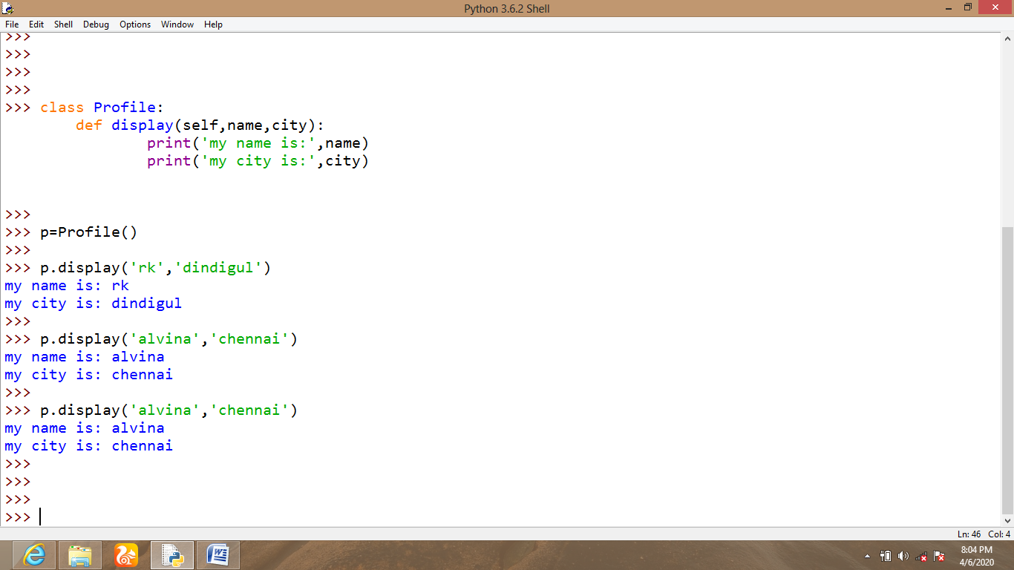
7.3 VARIABLES USED IN CLASS
There are three types of variables used in python,
Class variable
Instance variable
Variables accessed using global keyword
Class variable
A Variable is called as class variable if it is declared inside class and outside functions.
Class variables are open to access for all functions within same class.
Class variables are also known as Static variables
Instance variable
A Variable is called as instance variable if it is declared inside function of a class.
Instance variables are accessible only to the local function
Instance variables are also called as local variables
Global variable
If a variable is declared outside or anywhere inside the class which can be accessed using global keyword is possible in python.
